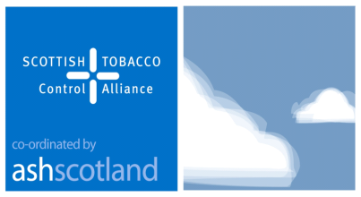

STCA Youth and Tobacco Forum
28th May 2014
Conference Room 3, Lynebank Hospital, Dunfermline

Theme: Approaches to multiple risk taking behaviours amongst young people

Agenda

9:30 Registration
10:00 Welcome and Introductions
Chiara Marin (Vice Chair, Youth and Tobacco Forum)
Volunteers’ Coordinator, Fast Forward

10:10 Tackling Smoking Prevention with Vulnerable Young People
Christine Boyle & Natalie Johnstone, NHS Lanarkshire
10:30 Multiple Risk Behaviours in Looked After Young People: a Focus on Tobacco
Hannah Dale, Health Psychologist, NHS Fife.
10:55 The Hub Drop-in Project
Tara Irvin, Health Promotion Officer, Children and Young People, Dunfermline and West Fife CHP, NHS Fife

11:15 Break
Tea/Coffee

11:30 Workshop: Risk Taking Behaviour Policy and Resources
Gael Cochrane, Children and Families Department, City of Edinburgh Council
12:30 Members Updates & Discussion

13:00 Close & Evaluations

13:15 Lunch
Sandwich Lunch

